1. SELECT job_seq , job_title FROM job, job_detail WHERE job_seq = '105’' ;

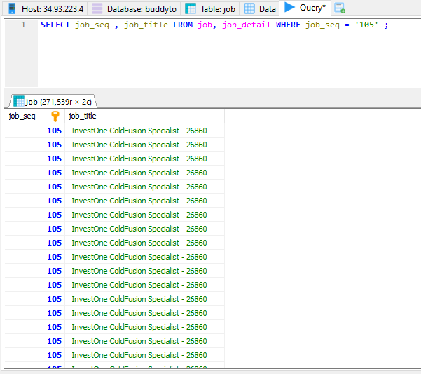

1. SELECT user_profile_seq , user_id FROM user_profile WHERE user_id = 'RAM@t366.com' ;

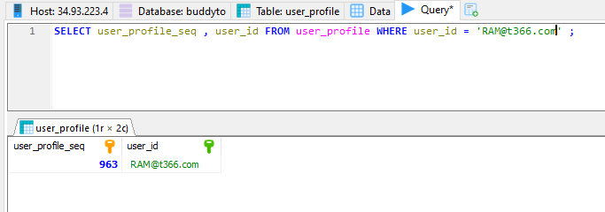

1. SELECT job_recrtr_seq, job_seq, user_profile_seq FROM job_recruiter WHERE job_recrtr_seq = '1009' ;

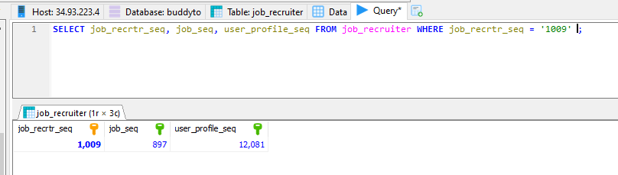

1. SELECT candidate_seq, user_profile_seq, first_name, last_name FROM candidate WHERE first_name = 'Kirtee' ;

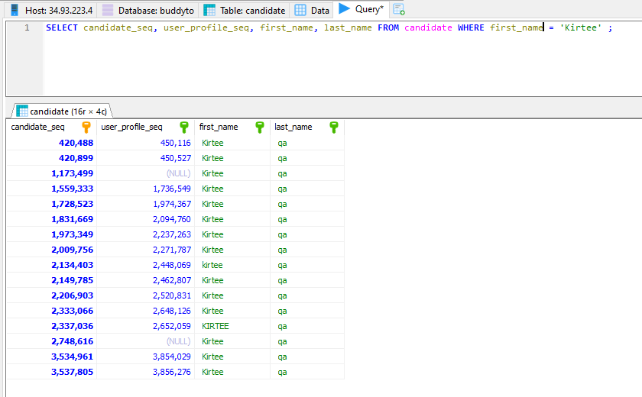

1. SELECT job_seq, company_mstr_seq = '2', job_title, job_status FROM job WHERE job_status = 'ACTIVE' ;

